IAG Mirth Extension Deployment Guide

Version 1.0



Copyright

This document is CitiusTech Confidential and contains proprietary information, including trade secrets of CitiusTech. Neither the document nor any of the information contained in it may be reproduced or disclosed to any unauthorized person under any circumstances without the express written permission of CitiusTech.

Revision History

|  |  |  |  |  |  |
| --- | --- | --- | --- | --- | --- |
| Document Version # | Revision Date | Prepared By | Approved By | Approval Date | Summary of Changes |
| 1.0 | 01-07-2020 | Akshaya Subramanian | Gaurav Chonkar | Click here to enter a date. | First Version |

Contents

1 Purpose 3

2 Deployment Requirements 4

2.1 Server Requirements 5

2.2 Software Pre-requisites 5

2.3 Client Environment Requirements 6

2.4 Deployment User Requirements 7

2.5 Port Requirements 7

Annexure 8

# Purpose

This document provides guidelines to import the GIT Plugin for Mirth Connect.

# Deployment Requirements

Below sections enlist the pre-requisites for the deployment.

## Server Requirements

The GIT Mirth Extension is primarily a zip file that will get imported using the Mirth UI for Extensions.

The process to install the extension is similar to the other commercial extensions made available by Mirth Connect. Mirth User Guide can be referred to installation/uninstallation of the extension

**<Screenshot for Mirth Extensions Page>**

## Installation Pre-requisites

This section refers to the pre-requisites that would be required for the installation of the extension

* Please ensure GIT repository is available to connect to.
* Please ensure users have commit and push permissions to the GIT repository
* Please ensure user has Mirth administration rights to be able to restart Mirth service post import of the zip file
* The trusted certificate needs to be installed in the System’s truststore.

## Client Environment Requirements

* There is no specific requirements, since this would reside in the Mirth Connect set up

## Deployment User Requirements

* The user needs to be a Mirth system administrator for installation and import of the zip file
* The user needs to import the certificate shared along with the zip

# Deployment Steps

Download the Mirth extension from

<https://github.com/SalmanCitiustech/Mirth-Connect-Extension---GIT/tree/GitPluginZip>

## Verify the contents of the Zip

The GIT plugin zip would consist of the below files

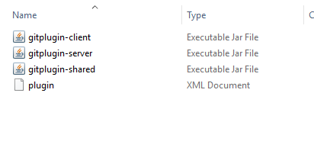

## Import the certificates

Download the certificate shared along with the zip and copy onto some location in the Mirth server.

### For Windows

#### Start the MMC

Open Windows+Run and type in mmc

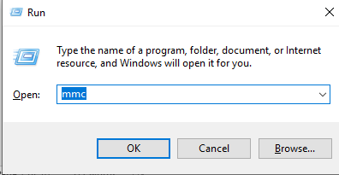

#### In the console Click on File->Add/Remove Snap-in

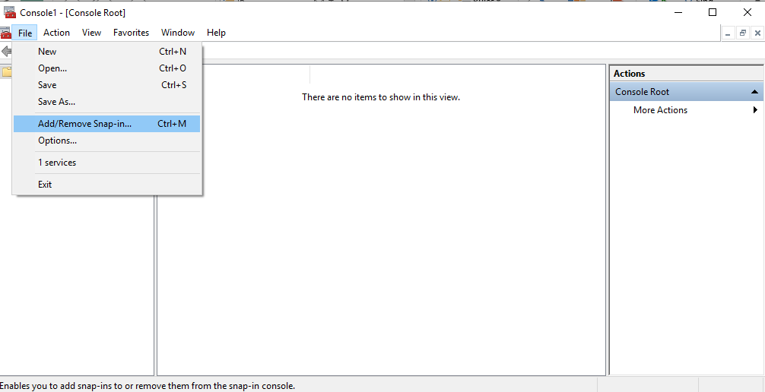

* Click on Certificates and Add

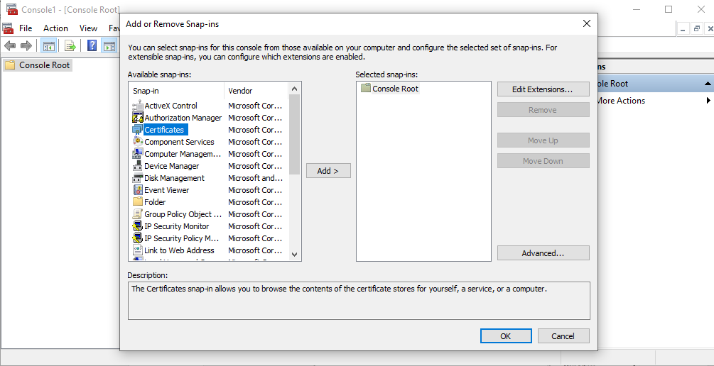

* Choose the Service Account or the Computer Account

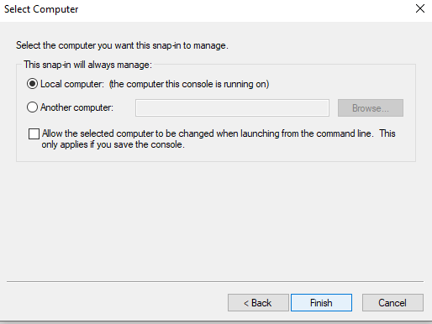

* Click on Ok

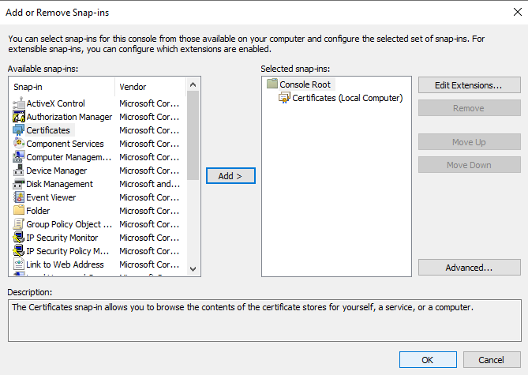

* Click on Certificates->Personal->Certificates

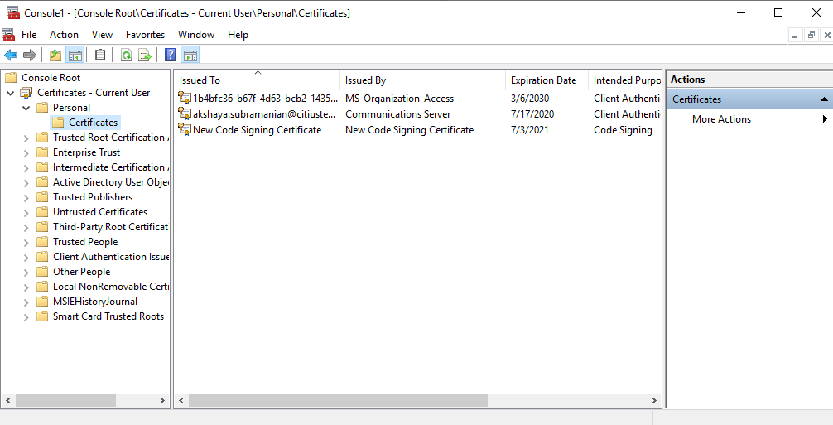

* Right click on Certificates->All Tasks-> Import

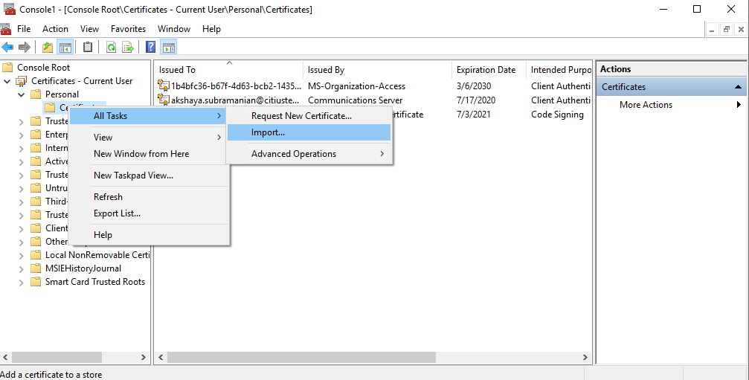

* A certificate import wizard gets launched

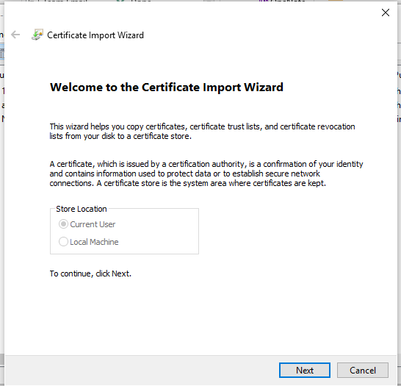

* Click on Next and choose the certificate that is part of the deployment package

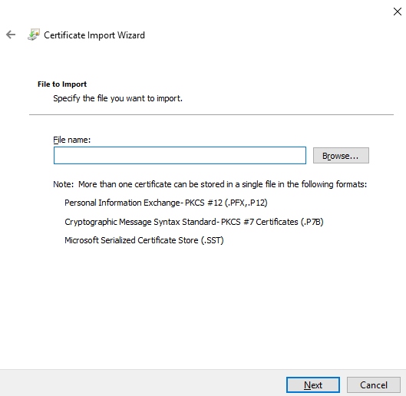

* Choose from the location where the certificate file is saved

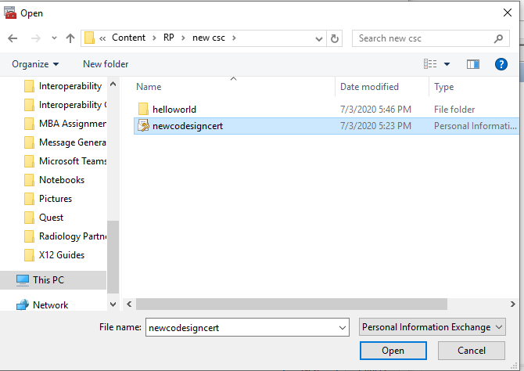

* Click on Next and type in the private password that will be shared separately

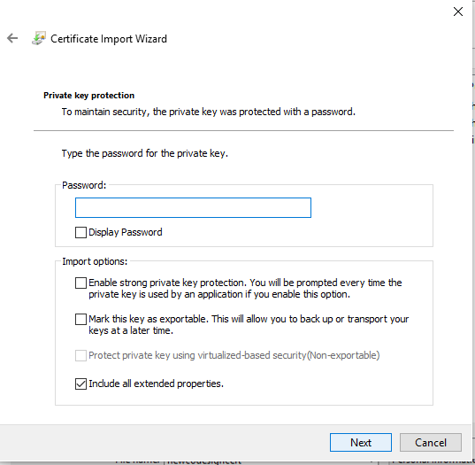

* Click on Next and choose the Personal certificate store

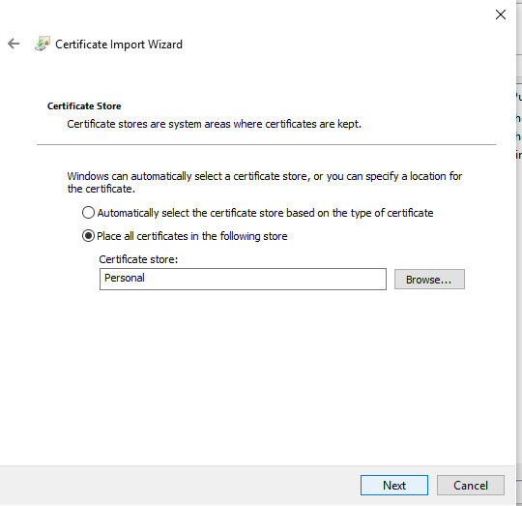

* Click on Next and then Finish

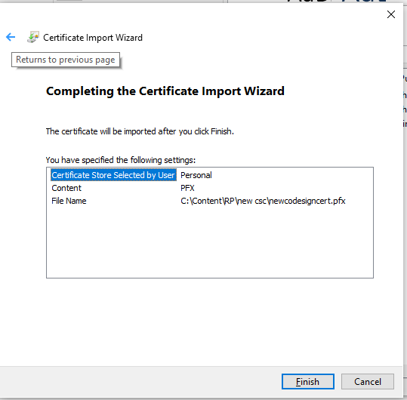

* You should see the certificate installed in the Personal store
* Right Click on the certificate and Copy

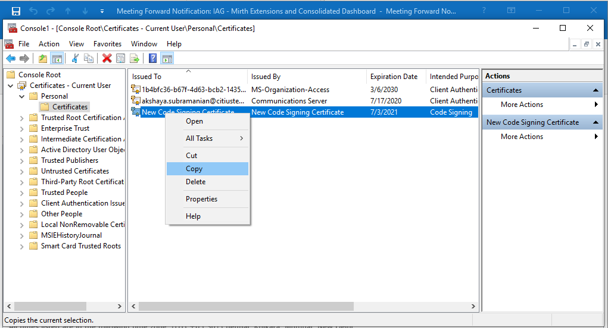

* Click on Trusted Root Certification Authorities -> Certificates
* Right Click and Paste

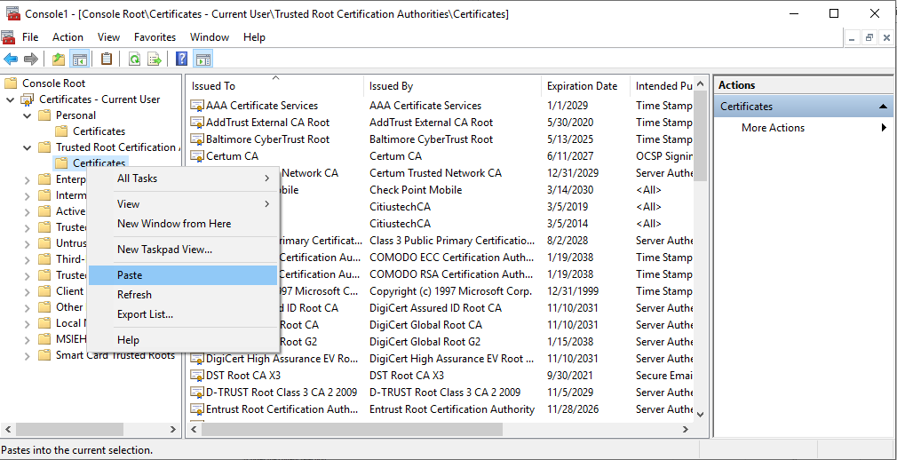

* The certificate would get copied in this location as well.

## Install the extension

* Launch the Mirth Connect administrator and login to the Mirth UI
* Click on the Extensions link in the task pane at the top left

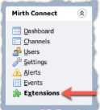

* This section is separated into the following topics:
  + Installed Connectors Table
  + Installed Plugins Table
  + Installing a New Extension
  + Extension Tasks

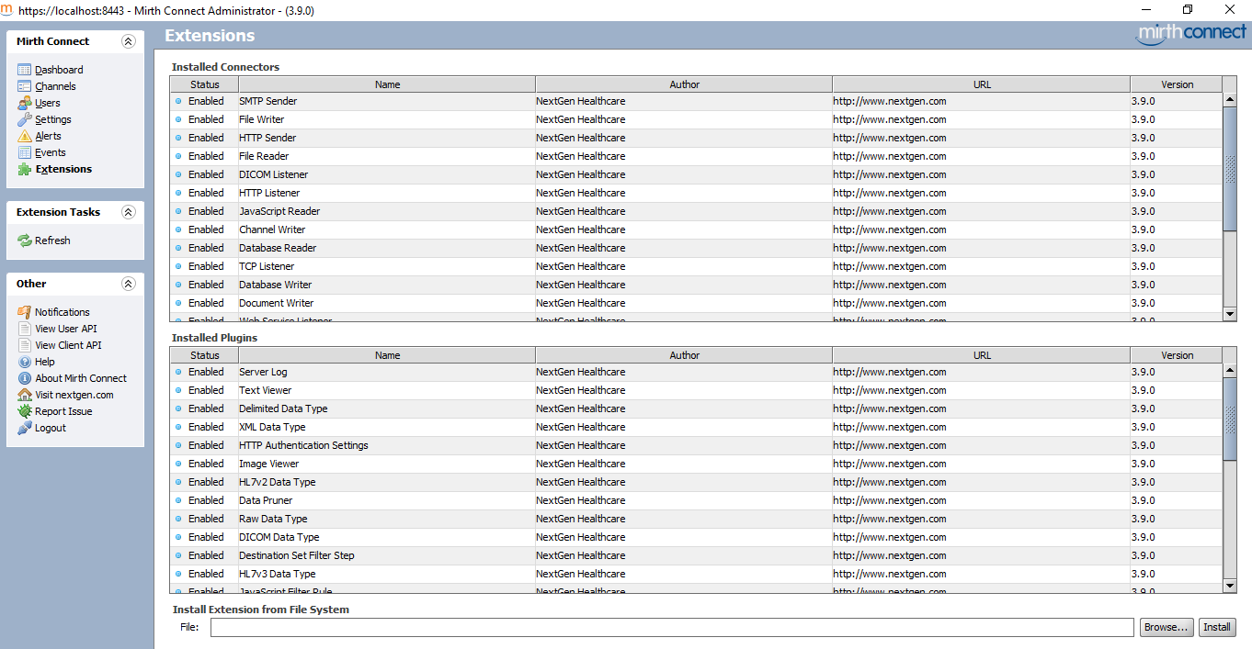

* Navigate to the “Intall Extension from File System” at the bottom



* Click on the “Browse” button and select the GITPlugin.zip file from the respective folder



* Click the “Install” button. You'll see a notification telling you to restart the server



* Restart the NextGen Connect Integration Engine server and launch the Mirth Connect Administrator You'll see the new extension listed in the Installed Plugins Table.

## Annexure

**Deployment Checklist**

This section provides the template for maintaining the details for each environment mentioned in section 2.1 (Separate row to be created for each environment).

|  |  |  |  |  |  |  |  |  |  |  |
| --- | --- | --- | --- | --- | --- | --- | --- | --- | --- | --- |
| **Sr No** | **Client Name** | **Environment** | **Machine name (IP Address)** | **Processor** | **# of Cores** | **Operating System** | **RAM** | **Total Hard Disk Space** | **Third Party Software Deployed** | **Solution Component Deployed** |
|  |  |  |  |  |  |  |  |  |  |  |
|  |  |  |  |  |  |  |  |  |  |  |
|  |  |  |  |  |  |  |  |  |  |  |
|  |  |  |  |  |  |  |  |  |  |  |
|  |  |  |  |  |  |  |  |  |  |  |